Title (Times, bold, 14pt)

Author(s) (Times, 14pt)

Affiliation(s): Times, 12pt, italic

Main text (Times, 12pt). Please submit a one-page abstract in A4 PDF format by email to apw-cems-abstract@riken.jp. The submission deadline is November 13, 2017. The acceptance of the abstracts will be noticed around November 21, 2017.
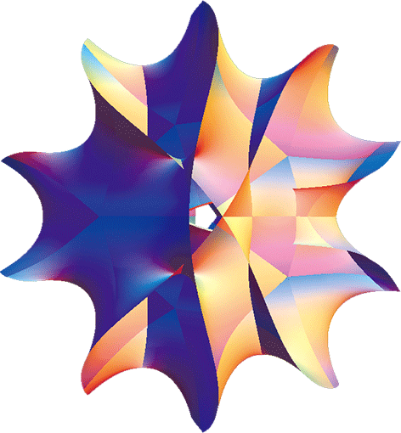
Fig. 1: Figure Caption
Abstract booklets will be printed in color. Resolution more than 300 dpi is desirable. (Times, 11pt)

References (If necessary): Times, 11pt
[1] Reference 1
[2] Reference 2

