Abstract Title
(Times, 14pt, bold)

C. E. M. S. Riken¹, J. Matsuno^{1,2}, and P. Mahadevan³
(Times, 14pt)

¹RIKEN Center for Emergent Matter Science (CEMS)
²Department of Physics, Osaka University
³S. N. Bose National Centre for Basic Sciences
(Times, 12pt, italic)

Please submit a one-page abstract in A4 format by email to the secretariat (indo-japan8@ml.riken.jp). The file type can be either PDF or MS-Word. The submission deadline is January 15, 2019.
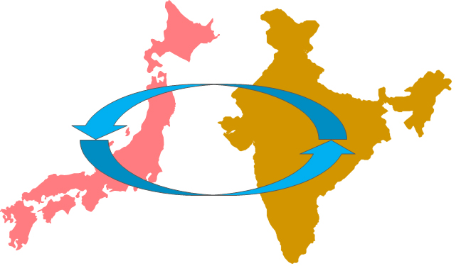The Indo-Japan Seminar “Designing Emergent Materials” will be held on January 31 – February 2, 2019 at University of Tokyo, Japan. This is the 8th workshop between India and Japan since 2006, which will bring together leading scientists from both countries carrying out research in the growing field of emerging materials (Fig. 1).
Fig. 1: Figure Caption
Abstract booklets will be printed in color.
(Times, 12pt)
This would serve as a platform for the generation of new ideas, possible collaborations including exchange of students and postdoctoral researchers. The broad theme of the seminar will be both the design of emerging materials as well as the physics behind the phenomena associated with them.
This symposium is organized by RIKEN CEMS [1] and supported by JSPS and DST under the Japan–India Science Cooperative Program.
(Times, 12pt)

[1] https://www.cems.riken.jp/

