Abstract Title
(Times, 14pt, bold)

Y. Iwasa¹, T. Machida², and M. Koshino³
(Times, 14pt)

¹RIKEN Center for Emergent Matter Science (CEMS)
²Institute for Industrial Science, The University of Tokyo
³Department of Physics, Tohoku University
(Times, 12pt, italic)

Please submit a one-page abstract in A4 format by email to the secretariat (cems_emer2d@riken.jp). The file type can be either PDF or MS-Word. The submission deadline is Friday 27th November.
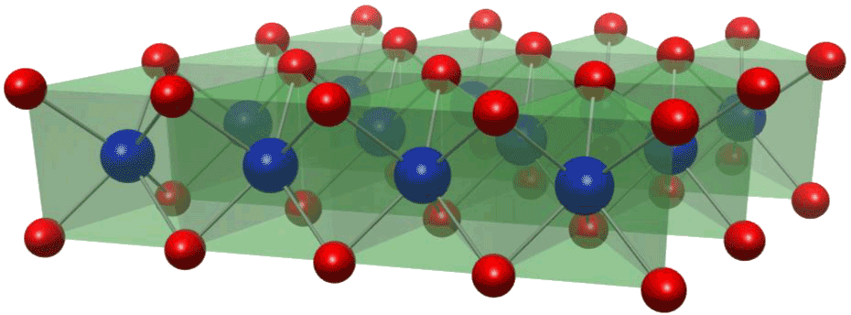
During the past decade, a tremendous progress has been made on atomically thin and highly crystalline materials, including graphene, transition metal dichalcogenides (TMD), topological insulators, and Fe-based superconductors, which are forming new families of two dimensional (2D) materials which are distinct from the conventional 2D systems formed at semiconductor heterostructures. More importantly, such a new class of 2D systems offers large playgrounds of rich unprecedented physics. This topical meeting was planned to provide a forum for researchers from different fields of 2D material systems and an opportunity to discuss the current state-of-art technology and future direction of the emergent 2D materials. The meeting covers a broad-range of topics including, valleytronics, superconductivity, mesoscopic transport, metal-insulator transitions, thermoelectric properties, optical properties of 2D materials. (Fig. 1).
Fig. 1: Figure Caption
Abstract booklets will be printed in color.
(Times, 12pt)
This topical meeting is organized by RIKEN CEMS [1] together with Grant-in-Aid for Scientific Research on Innovative Areas Ministry of Education, Culture, Sports, Science and Technology (MEXT) Science of Atomic Layers (SATL) [2].
(Times, 12pt)

[1] https://www.cems.riken.jp/
[2] http://flex.phys.tohoku.ac.jp/gensisou/

