Abstract Title
(Times, 14pt, bold)

Y. Iwasa¹, S. Sumizu¹, and T. Machida²
(Times, 14pt)

¹RIKEN Center for Emergent Matter Science (CEMS)
²Institute for Industrial Science, The University of Tokyo
(Times, 12pt, italic)

Please submit a one-page abstract in A4 format by email to the secretariat (cems_emer2d_2017@ml.riken.jp). The file type can be either PDF or MS-Word. The submission deadline is July 9th 2017.
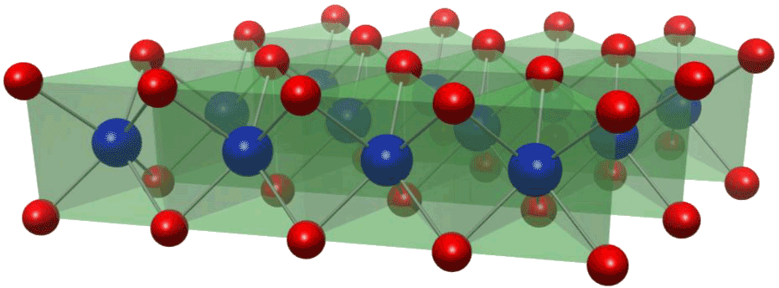
During the past decade, a tremendous progress has been made on atomically thin and highly crystalline materials such as transition metal dichalcogenides (TMD), topological insulators, and Fe-based superconductors. Such a new class of 2D systems have offered large playgrounds of rich unprecedented physics and triggered the development of novel experimental and theoretical approaches (Fig. 1).
Fig. 1: Figure Caption
Abstract booklets will be printed in color.
(Times, 12pt)
In 2015, the first Topical Meeting on “Emergent 2D Materials” was held to provide a forum for researchers from different fields of 2D materials systems. "Emergent 2D Materials 2017" aims to share the rapid development of this field since the previous meeting and to discuss the future direction of the emergent 2D materials.
The meeting covers a broad-range of topics including topological phenomena, superconductivity, mesoscopic transport, thermoelectric properties, optical properties, and device fabrications of 2D materials.
This topical meeting is organized by RIKEN CEMS [1].
(Times, 12pt)

[1] https://www.cems.riken.jp/

