Abstract Title
(Times, 14pt, bold)

K. Nakano¹, Y. Pu¹, and K. Tajima²
(Times, 14pt)

¹RIKEN Center for Emergent Matter Science (CEMS)
²Department of Applied Chemistry, The University of Tokyo
(Times, 12pt, italic)

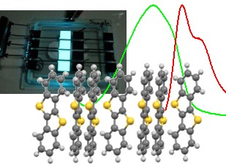
Please submit a one-page abstract in A4 format by email to the secretariat (cems_topical_meeting_2023@ml.riken.jp). The file type can be either PDF or MS-Word. The submission deadline is July 10th 2023.
Research on optoelectronic devices using organic semiconductors is at a mature stage, and researches aimed at applications such as display elements and lighting by organic light emitting devices, flexible integrated circuits by organic transistors, and self-sustaining power supplies by organic thin film solar cells are actively conducted in recent years. (Fig. 1).
Fig. 1: Figure Caption
Abstract booklets will be printed in color.
(Times, 12pt)
On the other hand, the research of organic electronics is subdivided, and it is necessary to have a comprehensive discussion on the essential physical properties of organic semiconductors that is commonly important for the applications.
This topical meeting provides an opportunity to discuss on the latest topics such as theoretical developments and trends in material design, control of material interfaces, and their optical analysis methods, with regard to the optoelectronic properties of organic semiconductors. We seek a wide range of opinions on the direction and future prospects of organic electronics.
This topical meeting is organized by RIKEN CEMS [1].
(Times, 12pt)

[1] https://www.cems.riken.jp/

